Chapter 7, Solution 35.

(a)
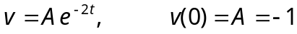
v(t) = –e^{–2t}u(t) V
(b)
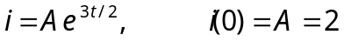
i(t) = 2e^{–1.5t}u(t) A

